# Application analysis

# Activity Diagram

Activity diagrams shows the different activities involved in the application. It also provides the clear overview of application from one starting point to end point. We use for five active diagrams to presents the workflow of each activities and actions with different choice. These five diagrams are used to explain registered, search, login, member management and item management those five different actions

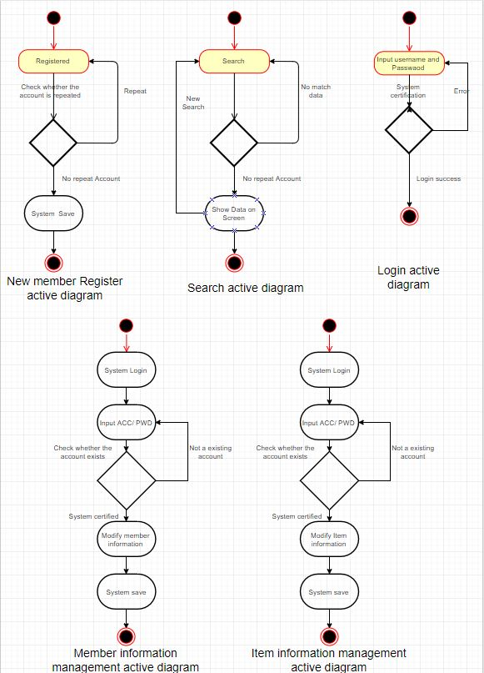

# Use case Diagram

In the process of project development, understanding the needs of users is a very important thing, but it is likely that even the user himself is not very clear what they need, therefore, we can use the use case diagram to assist in defining requirements. The diagram below shows the interaction in each actors and functions, we can see the buyer can interact with sign in, sign up, search, booking and order functions, those functions provider to buyer a car shopping environment to buyer. Admin interact with sign in, sign up and search, but also interact with item management and user management functions for Information management work. Seller also interact with sign in, sign up and item management functions, because in our system planning, the seller need provide the item(car) information to admin, and admin will help seller upload all the item information to application when the admin confirms the all of the relevant information, we hope that through such a mechanism to reduce the problem of deception.

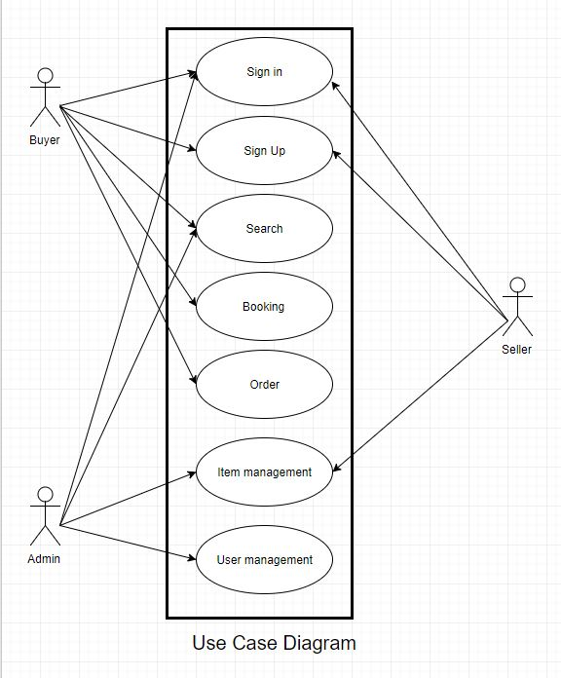

# State transition Diagram

State transition Diagram is a diagram to represent a machine that has a number of states, When the event occurs, the event will drive the machine to change his state. The diagram below show that start pint into the web application, when entering a different machine and through a different event selection will produce a different state.

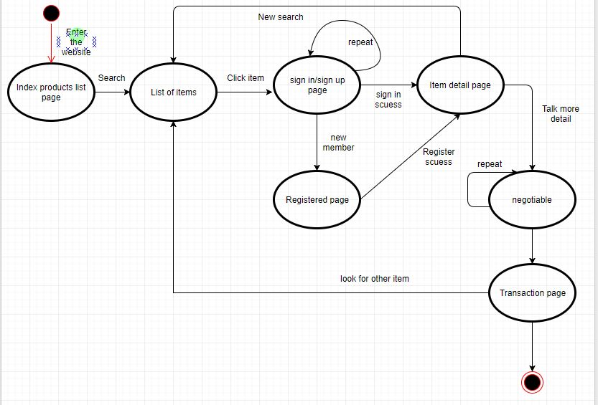

# Non-Functional requirements

1. maintenance

our team will follow four important rules to make sure our application will easily to maintain at future.

1. Easy to analyse: The defect or cause of failure in the software product diagnostic software or the ability to identify the part to be modified.
2. Easy to change: The software product enables the specified changes to be implemented by the ability to implement changes including coding, design and documentation
3. Stability: Software products avoid the ability to cause unexpected results due to software modifications.
4. Easy to test: The software product enables the ability to modify the software to be confirmed.
5. Reliability

We will through the reliability test to view the probability and availability of the software, The main purpose for our application reliability testing have three point.

1. Software needs to confirm if correctly implemented in the operating environment.
2. For software reliability estimate collect accurate data.
3. Through the software reliability test to find all the greater impact on the reliability of the software error
4. Test

We will through TDD (Test-Driven Development) to make sure all the function works smoothly, before we write the code, we use the test function in the visual studio to do some of test for make sure the function development will goes well.